CSET489: SEARCH ENGINE OPTIMIZATION
PRACTICAL MINI-PROJECT HANDBOOK & EVALUATION FRAMEWORK
Course Code: CSET489 | Credits: 3 (L-T-P-E: 3-0-0-0)
Component: Continuous Assessment (CA) – Mini-Project Case Study
Total Marks: 40 Marks
Evaluation Structure: Milestone I (20 Marks) + Milestone II (20 Marks)
Submission Mode: Individual Submission / Assigned Team Submission

Project Overview & Objective
The objective of this hands-on project is to develop a live, SEO-optimized website from scratch and deploy it on a Virtual Private Server (VPS). Students will execute an end-to-end SEO campaign, spanning niche selection, competitor analysis, keyword research, technical server configuration, on-page optimization, content creation, backlink placement on designated external domains, web analytics integration, and comprehensive SEO auditing.

2. Milestone Structure & Required Tasks
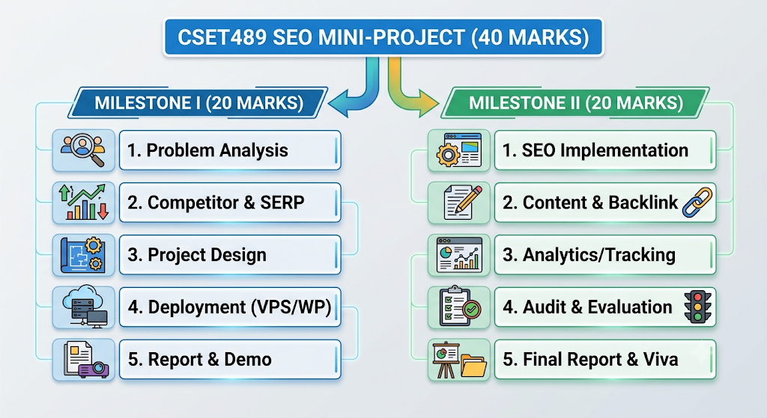
MILESTONE I: SEO Research, Analysis, Project Design & Deployment (20 Marks)
- Niche Identification & Problem Analysis (2 Marks):
  - Select a defined, evergreen niche or trending topic.
  - Identify target audience personas, search intent patterns, and clear SEO problem statements with 100–150 words of justification supported by data.
- Keyword Research & Search Intent (2 Marks):
  - Use tools such as Google Keyword Planner, SEMrush, Ubersuggest, KWFinder, or AnswerThePublic.
  - Compile 10–15 primary/focus and secondary keywords with Search Volume, Keyword Difficulty (KD, preferably KD < 20 for primary targets), and categorized intent (Informational, Commercial, Transactional, Navigational).
  - Provide a structured table of 5–10 long-tail and Latent Semantic Indexing (LSI) terms with competition and relevance scores.
- SERP & Ranking Analysis (2 Marks):
  - Perform a deep-dive SERP analysis for target keywords.
  - Examine top-ranking URLs, featured snippets, People Also Ask (PAA) boxes, content length, and structural patterns.
- Competitor Analysis & Content Gap (2 Marks):
  - Analyze 2 direct competitors: identify their top-ranking keywords, backlink profiles, and content gaps to discover ranking opportunities.
- Keyword-to-Page / Content Mapping (2 Marks):
  - Construct a complete architectural site hierarchy and URL taxonomy.
  - Map primary, secondary, and LSI keywords to specific pages (Homepage, About, Services/Categories, Blog posts) without keyword cannibalization.
- SEO Strategy & Implementation Plan (2 Marks):
  - Document a prioritized, chronological SEO roadmap outlining technical fixes, content rollout, on-page optimization, and planned off-page efforts.
- Domain, DNS & Cloudflare Configuration (2 Marks):
  - Register a custom domain (via Namecheap, Spaceship, InternetBS, etc.).
  - Configure nameservers and DNS records through Cloudflare (enabling CDN, Full/Strict SSL, minification, and caching rules). Verify DNS propagation.
- VPS Deployment & Functional Website Setup (2 Marks):
  - Provision a cloud VPS instance (DigitalOcean, AWS Lightsail, Vultr, etc.).
  - Configure web server stack (LEMP/LAMP/OpenLiteSpeed), MySQL/MariaDB, and PHP. Install SSL via Let's Encrypt / Certbot.
  - Deploy a fresh, functional WordPress installation. Provide SSH terminal logs/command evidence.
- Documentation, Proof & Evidence Quality (2 Marks):
  - Well-organized technical documentation, terminal logs, DNS propagation screenshots, and keyword matrices.
- Milestone I Demonstration & Timely Submission (2 Marks):
  - Walkthrough of the live site, server configuration, and keyword research rationale.

MILESTONE II: SEO Implementation, Content, Backlinking, Analytics & Evaluation (20 Marks)
- Technical & On-Page SEO Implementation (2 Marks):
  - Configure SEO plugins (Rank Math or Yoast SEO).
  - Optimize page titles, meta descriptions, OpenGraph tags, heading hierarchy (H1, H2, H3), breadcrumbs, SEO-friendly permalinks, and XML sitemaps.
  - Implement structured data / Schema Markup (Organization, Article, WebSite, JSON-LD) verified using Google's Rich Results / Schema Validator.
- Performance, Security & Core Web Vitals Optimization (2 Marks):
  - Configure caching (LiteSpeed Cache / WP Super Cache) and image compression/WebP conversion (Smush, ShortPixel).
  - Demonstrate measurable performance testing via Google PageSpeed Insights & GTmetrix (LCP, FID/INP, CLS) with before/after comparisons.
- Keyword-Based Content Creation (2 Marks):
  - Publish original, high-quality content aligned directly with the keyword strategy established in Milestone I.
  - Mandatory pages: Homepage, About Us page, and at least one in-depth, search-intent-optimized Blog Article.
  - Content must exhibit proper keyword density, internal linking, authoritative outbound citations, and optimal readability.
- Backlink Implementation & Off-Page Contribution (2 Marks):
  - Publish/contribute high-value, niche-relevant content on the instructor-designated external domain(s).
  - Embed a contextually relevant, do-follow backlink pointing back to your project site using natural, diverse anchor text.
  - Provide verifiable live URLs and indexed proof.
- Analytics & Google Search Console Integration (2 Marks):
  - Install and verify Google Search Console (GSC) using DNS/HTML verification. Submit the XML sitemap.
  - Deploy Google Analytics 4 (GA4) property tracking. Verify real-time tracking, custom event tagging, and user engagement collection.
- Performance Reporting & Ranking Analysis (2 Marks):
  - Present empirical data from GSC and GA4: index status, queries, impressions, clicks, CTR, and keyword rank positioning.
- SEO Audit & Issue Identification (2 Marks):
  - Conduct a comprehensive technical and on-page audit using tools like Screaming Frog, Ahrefs Webmaster Tools, or SEMrush Site Audit.
  - Identify crawl errors, broken links, redirect chains, missing alt attributes, and thin content.
- Optimization & Corrective Actions (2 Marks):
  - Document and deploy systematic fixes for issues discovered during the audit. Evaluate the measurable impact of improvements.
- Full Project Documentation & Updraft Backup (2 Marks):
  - Final comprehensive report synthesizing all phases.
  - Full site & database backup created using UpdraftPlus (.zip), uploaded to Google Drive with an open, accessible public link.
- Final Demonstration, Viva & Defense (2 Marks):
  - 5–7 minute final viva presenting the live website, analytics dashboards, schema validation, backlink verification, and critical reflections.

3. Detailed Evaluation Rubric Matrix (Table-1 Performance Descriptors)
Each sub-criterion is assessed on a 4-level scale: Excellent (2.0), Good (1.5), Acceptable (1.0), and Poor (0.0).
MILESTONE I RUBRICS (20 MARKS)
Criterion | Sub-Criterion | Excellent (2.0) | Good (1.5) | Acceptable (1.0) | Poor (0.0)
Problem Analysis (4 Marks) | Niche, Audience & SEO Problem | Clearly identifies a specific niche, target audience, and SEO problem; provides solid justification supported by data. | Niche, audience, and SEO problem identified with adequate justification; minor gaps in evidence. | Niche is identified, but target audience/problem or justification is incomplete. | Niche/problem is unclear, inappropriate, or missing.
 | Keyword Research & Search Intent | Comprehensive keyword set with relevant long-tail & LSI keywords, search volume/KD evidence, and clear intent classification. | Appropriate keyword set with search-intent classification and metrics; minor gaps. | Limited keyword set or incomplete intent/metric analysis. | Irrelevant, insufficient, or missing keyword research.
Competitor & SERP Analysis (4 Marks) | SERP Analysis | Systematically analyzes top-ranking SERP results; identifies ranking factors and content patterns with evidence. | Analyzes relevant SERP results with appropriate observations; minor analytical gaps. | Basic SERP comparison with limited interpretation. | Minimal or no meaningful SERP analysis.
 | Competitor Analysis | Thoroughly analyzes competitor keywords, backlinks, and content gaps; uncovers actionable opportunities. | Appropriate competitor analysis with some actionable findings. | Basic competitor comparison with superficial insight. | No meaningful competitor analysis.
Project Design (4 Marks) | Keyword-to-Page Mapping | Perfectly maps target keywords and search intent to website pages/topics without duplication/cannibalization. | Appropriate mapping with minor structural gaps. | Partial mapping with weak connection to search intent. | No meaningful keyword/page mapping.
 | SEO Strategy & Roadmap | Clear, logically prioritized roadmap covering technical, on-page, content, and off-page activities. | Appropriate plan covering major SEO tasks with minor prioritization issues. | Basic plan with limited prioritization or coverage. | No coherent SEO implementation strategy.
Project Implementation (4 Marks) | Domain, DNS & Cloudflare | Domain, DNS, and Cloudflare CDN/SSL are correctly configured; website resolves cleanly; evidence provided. | Configuration substantially correct with minor DNS/caching issues. | Partial configuration; unresolved propagation or SSL warnings. | Configuration incomplete; website inaccessible.
 | VPS & WordPress Setup | VPS environment configured via SSH; WordPress cleanly deployed, functional, and verified with command logs. | WordPress/VPS deployment functional with minor config issues. | Partial deployment or unresolved server configuration issues. | Deployment not completed or non-functional.
Documentation & Demo (4 Marks) | Evidence & Submission Quality | Complete, well-organized evidence: screenshots, tables, logs, and traceable deliverables. | Most required evidence provided and logically arranged; minor omissions. | Significant evidence gaps or poorly organized submission. | Minimal or missing evidence.
 | Milestone Demo & Timeliness | Demonstrates live setup confidently; explains architectural decisions accurately; submitted on time. | Demonstrates project adequately and submits on time with minor shortcomings. | Partial/unclear demo; avoidable submission issues. | Unable to demonstrate work or milestone not submitted.

MILESTONE II RUBRICS (20 MARKS)
Criterion | Sub-Criterion | Excellent (2.0) | Good (1.5) | Acceptable (1.0) | Poor (0.0)
SEO Implementation (4 Marks) | Technical & On-Page SEO | Flawlessly implements metadata, heading structure, XML sitemaps, clean permalinks, Schema JSON-LD, and internal links. | Major SEO elements correctly implemented with minor errors. | Partial implementation with several missing/incorrect tags. | Little or no meaningful on-page/technical SEO.
 | Performance & Security | Implements SSL, LiteSpeed/caching plugins, image optimization; demonstrates measurable PageSpeed gains. | Optimizations implemented with minor gaps and supporting test evidence. | Partial optimization; slow load times or limited testing. | Optimization not implemented or not tested.
Content & Backlinks (4 Marks) | Keyword-Based Content | Original, high-utility content aligned with researched keywords and intent; optimal headings, readability, and media. | Relevant, original content with appropriate keyword usage; minor gaps. | Content shows limited alignment with keyword intent or proper formatting. | Copied, keyword-stuffed, low-quality, or missing content.
 | Backlink Implementation | High-value content published on designated external domain with contextual, relevant backlink and anchor text. | Required backlink successfully placed with minor placement/relevance flaws. | Backlink present, but context, relevance, or anchor text is weak. | Required backlink missing, dead, or unverifiable.
Analytics & Tracking (4 Marks) | GSC & GA4 Integration | GSC & GA4 verified correctly; sitemaps indexed; real-time event tracking and Search Console data verified. | Tracking configured correctly with minor data stream issues. | Incomplete setup; limited evidence of active data collection. | Analytics/GSC tracking not implemented.
 | Performance Reporting | Clear before/after data using impressions, clicks, average position; thoughtful interpretation of SEO impact. | Relevant performance metrics presented with reasonable interpretation. | Limited performance data or purely descriptive reporting. | No meaningful performance reporting.
Audit & Optimization (4 Marks) | SEO Audit & Issue Detection | Systematic site audit covering technical, on-page, mobile, and link health; categorized and prioritized issues. | Covers most audit areas and identifies key technical/on-page issues. | Superficial audit; poor prioritization of errors. | Minimal or no meaningful SEO audit.
 | Corrective Optimization | Deploys validated corrective fixes; evaluates impact using evidence; identifies successes and limits. | Implements solid improvements with reasonable evaluation. | Minor improvements made; lacks impact evaluation. | No meaningful corrective actions taken.
Report & Communication (4 Marks) | Final Documentation & Backup | Comprehensive end-to-end report + functional UpdraftPlus backup link (.zip) shared with public access. | Documentation covers most areas with adequate evidence; backup intact. | Incomplete report or broken/restricted Google Drive backup link. | Minimal or missing report and backup.
 | Final Viva & Defense | Confidently demonstrates live site, defends architectural/SEO choices, and answers technical viva questions. | Demonstrates project adequately and answers questions with minor gaps. | Weak demonstration or difficulty explaining SEO strategies. | Unable to demonstrate work, absent from viva, or no submission.

4. Milestone Submission Guidelines & Late Policy
- Submission Format: Single structured PDF or DOCX report + Live Website URL + Public Google Drive link to UpdraftPlus full backup archive (.zip).
- File Naming Convention: CSET489_SEO_Assignment_[RollNo]_[YourName].pdf
- Milestone Submission Windows:
  - Milestone I Deadline: End of Teaching Week 7 / Session 18
  - Milestone II Final Deadline: Teaching Week 14 / Session 41 (before final showcase)
- Official Late-Submission Deductions (applied strictly to the final awarded mark):
  - On-time submission: No penalty.
  - 1 Day Late: -0.25 Marks.
  - 2–3 Days Late: -0.50 Marks.
  - 4–5 Days Late: -1.00 Mark.
  - 6–7 Days Late: -2.00 Marks.
  - More than 7 Days Late: 0 Marks awarded (Submission rejected).

Reference Links Summary for LMS Embed
Tutorial Title | Topic / Step Covered | YouTube URL
Video 1 | Domain Availability Tools & Ideation | http://www.youtube.com/watch?v=1jXDrpas5ak
Video 2 | Domain Deals & Registration | http://www.youtube.com/watch?v=ixNHdQT8hMA
Video 3 | Cloudflare Setup & DNS Management | http://www.youtube.com/watch?v=-6szrfoqLA4
Video 4 | SSH Key Generation & Authentication | http://www.youtube.com/watch?v=gNIAFT2HGAA
Video 5 | Droplet Creation (DigitalOcean) | http://www.youtube.com/watch?v=jSTOnt-l8nU
Video 6 | WordPress Deployment (DigitalOcean VPS) | http://www.youtube.com/watch?v=QQJaX2FoXGc
Video 7 | WordPress Deployment (MS Azure VPS) | http://www.youtube.com/watch?v=9ClruSZgZBQ
Complete Playlist | All Step-by-Step Practical Labs | https://www.youtube.com/playlist?list=PLkp7D8a8I7CDVIOlcuGhe_WNgPdqhaeaH

